Roadmap and Industry Action Plan for Future Manufacturing-as-a-Service
We are currently at the start of two major, complementary transitions driven by digitalisation and by the need to be more sustainable. Already these two transitions are having major impacts on the European manufacturing industry driving more digitised industrial production and leading to new models such as Manufacturing-as-a-Service. At the same time the move towards more climate neutral, circular and digitised industrial production is radically changing how manufacturers produce products. These fundamental changes are challenging existing linear models based on centralised manufacturing approaches. As a result of this the EC funded MASTT2040 project has been investigating how distributed MaaS approaches can be exploited by industry to provide more flexible, resilient and efficient manufacturing of products while also considering how industry can embrace the Circular Economy to create a more sustainable future.

The talk will give an overview of the work performed in MASTT2040 and introduce the Roadmap and Industry Action Plan for Manufacturing-as-a-Service supporting the twin transition up to 2040. This will highlight that Manufacturing-as-a-Service business models offer advantages with respect to resilience of supply chains and that circular manufacturing approaches offer a means of addressing critical raw materials shortages which fits well with respect to the next framework programme's Competitiveness Compass and EC Defence goals. The work has identified that data is key and that in future we will need a lot more data exchange between companies as MaaS business models move up the food chain making subassemblies and full products. This naturally leads to the need for Trusted Industrial Dataspaces. At the same time data exchange is highly important for sustainability and circularity. Data standards will thus be a key enabler and also regulations (the Data Act to share data, the Cyber Resilience Act for data security, the AI Act as AI will be everywhere, and Digital Product Passports for circularity).

Biopic
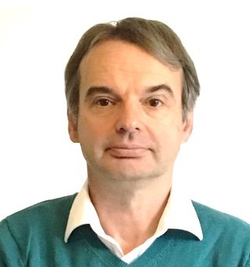
Professor Haydn Thompson, BSc, PhD. CEng has over 35 years’ experience working in a mixture of senior industrial research and development roles in flight control systems, space programmes and signal processing applications for leading companies. For nearly 20 years he was the Programme Manager of the Rolls-Royce Control and Systems University Technology Centre addressing research and innovation. Currently he is Managing Director and Owner of the THHINK group of companies, as well as being Managing Director and Owner of Haydn Consulting Ltd. He is recognised and used by the European Commission as an expert in many fields and is a consultant to a range of companies and government bodies. He defines Strategic Technology Roadmaps across Europe and for companies such as Rolls-Royce. In recent years he wrote the European Chips Act SWD, Recommendations and Roadmap for a Design Platform to support the European Chips Act and Recommendations and Roadmap for European Sovereignty in Open Source Hardware, Software, and RISC-V Technologies. He is also engaged by the EC as an Expert writing reports and evaluating proposals covering a number of areas including Artificial Intelligence and Robotics, Edge Computing, Advanced Computing, Internet of Things, Digitalisation of Industry, 5/6G and Green digital policy.

