TECoSA researcher affiliation: Offer, expectations and formalities
Introduction to TECoSA
TECoSA offers KTH researchers to become affiliated with the center and its activities. This two-pager describes what’s in it for you (why join), what the expectations are and how to make it happen.
TECoSA is a KTH based multidisciplinary research center, with long term funding by Vinnova, the Swedish Innovation Agency. TECoSA was inaugurated in March 2020 and currently (April 2022), has 15 industrial partners and involves multiple research groups at KTH (www.tecosa.center.kth.se/). TECoSA pursues needs driven research in the area of industrial applications of edge-based cyber-physical systems with a focus on ensuring the trustworthiness of such systems.
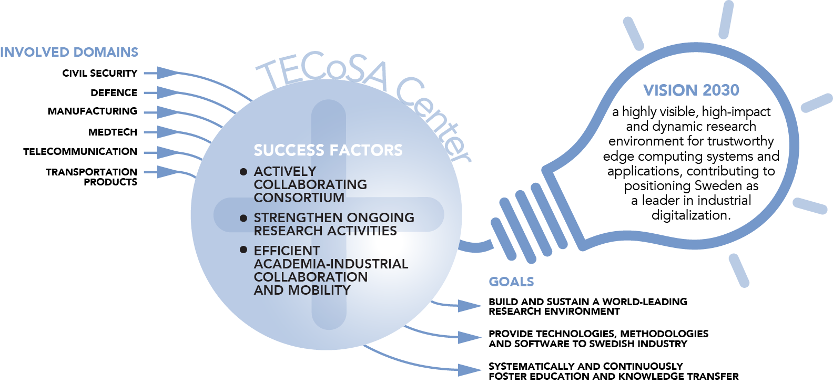
The vision of TECoSA is to establish a high-impact research environment on trustworthy edge-based systems, contributing to positioning Sweden as a leader in industrial digitalization.
Activities within TECoSA include
- A competence network with courses, partner meetings, a seminar series and workshops – promoting learning, experience exchange and collaboration
- Collaborative research
- Open testbeds to support research, education and innovation
The offer – Why become an affiliated researcher?
TECoSA offers KTH researchers to become affiliated with the center and its activities, providing in particular the following opportunities:
- Joining the competence network of TECoSA consisting of (currently) 15 industrial partners and 9 KTH-based research groups, with opportunities to improve their contact networks and for initiating new collaborations. Concretely, affiliated researchers will receive information about ongoing activities be invited to TECoSA events including the quarterly meetings. Affiliated researchers will also be mentioned on the TECoSA web and relevant initiatives will be promoted e.g. by inclusion in the newsletter.
- Opportunity to contribute to TECoSA educational efforts, e.g. graduate courses and seminars.
- TECoSA has developed edge-computing testbeds with 5G and several application domains at the KTH campus. Affiliated researchers will have free access to use these testbeds (given appropriate sharing among involved researchers) for experiments and are welcome to join and contribute to the testbed developments and long-term evolution.
- Leveraging the network to initiate new projects with partners, for example through industrial PhD students and TECoSA SME-projects. For SME projects, Vinnova has special funding for TECoSA SME-partners to engage in research. TECoSA will provide a financial incentive for TECoSA researchers (including affiliated) that drive and engage in SME-projects.
- Potential opportunity in engaging in supervision of existing and new PhD students
Expectations when joining as an affiliated researcher?
The pre-requisite for joining should be real interests in TECoSA related topics, testbeds and projects. Affiliated researchers are expected to engage in one or more TECoSA activities and to strive for collaboration in the context of TECoSA. A main expectation is that affiliated researchers are strengthening the environment (research, affiliated projects, inputs to quarterly meetings, workshops etc) and have the goal of active participation in the TECoSA quarterly meetings.
Affiliated researchers agree that TECoSA will display their names on the TECoSA web and use them in presentations/reports to describe involved affiliated researchers and their engagements in TECoSA.
Affiliated researchers will acknowledge support from TECoSA for relevant publications, e.g. those relating to use of TECoSA testbeds. Affiliated researchers are finally expected to be aware of the few formal rules that guide work in TECoSA, including confidentiality (specifically for information shared from industrial partners) IP questions. This is formalized by signing the corresponding researcher agreement for TECoSA.
Process for becoming an affiliated researcher
Preparation: Read up on the offer and expectations - Discuss with TECoSA management, TECoSA researcher and/or a TECoSA industrial partner
- Submit the following:
  - a (short) motivation why you want to join TECOSA as an affiliated researcher including a mentioning of a “sponsor” (KTH or industry person within TECoSA)
  - append this document signed, and a CV or a link to an existing CV (no special requirements on the CV, preferably a 1-2 pager)
- The TECoSA board makes a decision for approving affiliation
- You will be expected to sign the TECoSA researcher agreement summarizing the TECoSA partner agreement including considerations for confidentiality and intellectual property.
Contact persons:
- TECoSA directors: Martin Törngren (martint@kth.se), James Gross (james.gross@ee.kth.se)
- All TECoSA Pis: https://www.tecosa.center.kth.se/kth-researchers/
- TECoSA board chair: Catrin Granbom (catrin.granbom@ericsson.com)

Signature and date

_______________________________________

Full name

_______________________________________

