TECoSA researcher affiliation: Offer, expectations and formalities
Introduction to TECoSA
TECoSA offers KTH researchers to become affiliated with the center and its activities. This one-pager describes what’s in it for you (the why to join), what the expectations are and how to make it happen.
TECoSA is a KTH based multidisciplinary research center, with long term funding by Vinnova, the Swedish Innovation Agency. TECoSA was inaugurated in March 2020 and currently (April 2022), has 15 industrial partners and involves multiple research groups at KTH (www.tecosa.center.kth.se/).
TECoSA pursues needs driven research in the area of industrial applications of edge-based cyber-physical systems with a focus on ensuring the trustworthiness of such systems.
The vision of TECoSA is to establish a high-impact research environment on trustworthy edge-based systems, contributing to positioning Sweden as a leader in industrial digitalization.
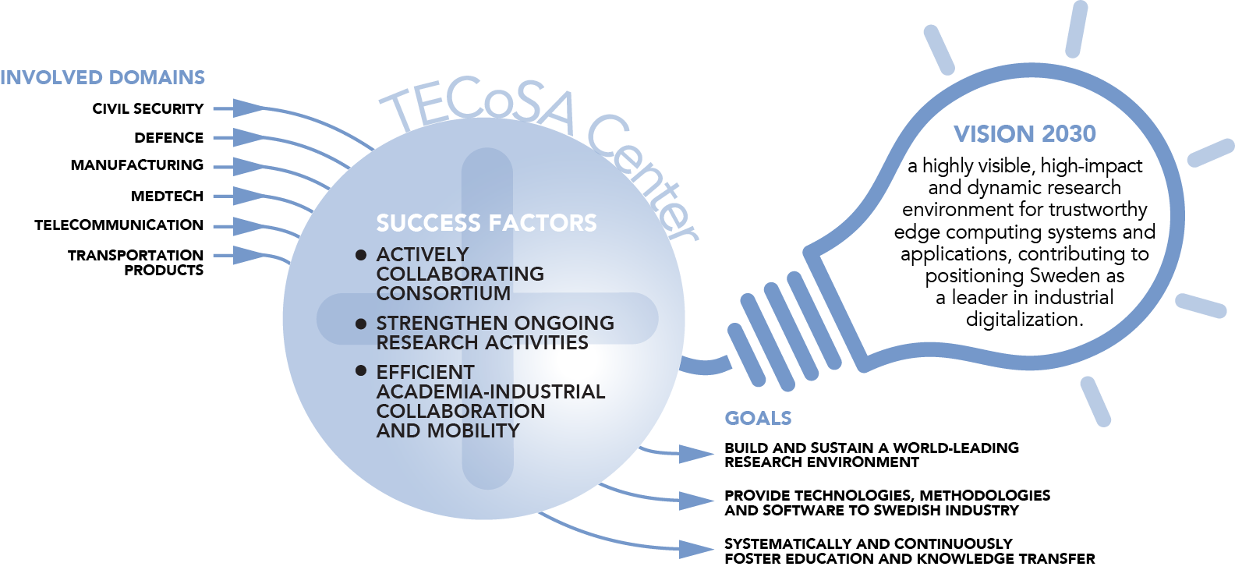
Activities within TECoSA include
- A competence network with courses, partner meetings, a seminar series and workshops – promoting learning, experience exchange and collaboration
- Collaborative research
- Open testbeds to support research, education and innovation
The offer – Why become an affiliated researcher?
TECoSA offers KTH researchers to become affiliated with the center and its activities, providing in particular the following opportunities:
- Joining the competence network for establishing connections to the industrial partners and other research groups.
- Leveraging the network to initiate new projects with partners, for example, industrial PhD students and TECoSA SME-projects (Vinnova has a separate budget for TECoSA SME-partners for them to engage in TECoSA research)
- Joining existing use-case and testbed projects in TECoSA including with opportunities to contribute to and/or use the TECoSA testbeds. With “Joining” with mean primarily contributing efforts (inkind hours) in contributing to the project(s).
- Potential involvement in supervision of existing PhD students
Expectations when joining as an affiliated researcher?
The pre-requisite for joining should be real interests in TECoSA related topics and related testbeds and projects. Affiliated researchers are expected to engage in one or more TECoSA activities and to strive for collaboration in the context of TECoSA.
Affiliated researchers are also expected to be aware of the few formal rules that guide work in TECoSA, including preserving any confidentiality in information shared from industrial partners.
Process for becoming an affiliated researcher
Preparation: Read up on the offer and expectations - Discuss with TECoSA management, TECoSA researcher and/or a TECoSA industrial partner
- Submit the following:
  - a (short) motivation why you want to join TECOSA as an affiliated researcher including a mentioning of a “TECoSA sponsor” (KTH or industry person within TECoSA)
  - append this document signed, and a CV or a link to an existing CV (not special requirements on the CV, preferably a 1-2 pager)
- The TECoSA board makes a decision for approving affiliation
- Finally, you will be expected to sign the TECoSA researcher agreement summarizing the TECoSA partner agreement including considerations for confidentiality and intellectual property.

Contact persons:
- TECoSA directors: Martin Törngren (martint@kth.se), James Gross (james.gross@ee.kth.se)
- All TECoSA Pis: https://www.tecosa.center.kth.se/kth-researchers/
- TECoSA board chair: Catrin Granbom (catrin.granbom@ericsson.com)

Signature and date

_______________________________________

Full name

_______________________________________

